PD: General Lab Safety Workshop

Speaker: Ellen Elsbernd, Chief OSHA Compliance Officer, UC Environmental Health and Safety
Date: Monday, June 10, 2019
Time: 1-2:30 PM
Venue: University of Cincinnati, Baldwin Hall, Room 741

Prepared by:
Akshayaa Venkatakrishnan, Dater High School, Cincinnati, Ohio
RET Participant for Project #1: Engineering Aligned, Bioactive Polymers for Peripheral Nerve Repair

This session was presented by Ellen Elsbernd, who is the Chief OSHA Compliance Officer at the University of Cincinnati (UC) Department of Environmental Health and Safety on Monday, June 10, 2019 from 1-2:30 PM at the University of Cincinnati in Baldwin Hall, room 741. This presentation was given on the first day of the RET program at UC in order to provide participants with an understanding of work-related routes of exposure to hazardous chemicals and how to take action to reduce exposure, dispose of chemical waste, and prepare in the case of emergencies.

Prior to her work in the field, Ms. Elsbernd was a high school chemistry teacher, and relayed background information about her experiences in the classroom that was pertinent to her current role. Ms. Elsbernd prioritizes making sure that employees and researchers are informed of the proper procedures for handling and disposing hazardous materials in order to have the right of a safe workplace. The overview she provided followed OSHA guidelines for Hazard Communication and Laboratory Standards. In Figure 1 below, Ms. Elsbernd is pictured going over policy and procedure changes to OSHA standards in 2012 in order to align to global standards; this adjustment ensured that all people who are compliant to OSHA regulations can practice in their field regardless of their location in the world.

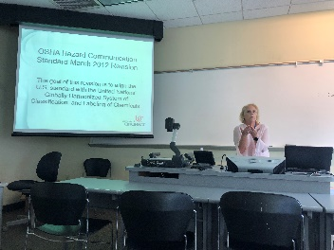

Fig. 1: Ellen Elsbernd reviews the 2012 revisions to OSHA Hazard Communication Standards.

The first major topic of discussion was ensuring that all participants understood the definition of hazardous chemicals and the harmful consequences and adverse changes that they can cause on the body. All participants were provided with an outline of Ms. Elsbernd’s presentation to keep track of different health effects. Acute and chronic effects were differentiated as rapidly occurring effects and long-term effects respectively, and different health effects were categorized based on the level of adverse change the hazardous chemical could have on the body. The three categories discussed were systemic effects, which could include carcinogens and corrosive agents, target organ effects, which includes nephrotoxin and neurotoxin, and other effects, which could include reproductive toxins and mutagenic toxins. Other categories of hazards included physical hazards like fire, explosion, and reactive hazards. These categories were important for participants’ general awareness and to be best prepared for any lab setting we encounter. Ms. Elsbernd also reviewed routes of exposure to chemical hazards, as displayed in Figure 2. This gave us further information on the role of her office in conducting and monitoring personal exposure levels.
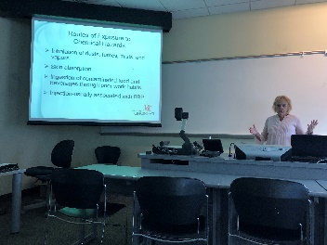

Fig. 2: Ellen Elsbernd reviews routes of exposure to chemical hazards.

Following an overarching review of the effects of chemical hazards, Ms. Elsbernd reviewed methods for identifying hazards and ensuring a safe lab environment. A key criterion for a safe and prepared lab environment that is especially relevant for science teachers is an inventory of Safety Data Sheets (MSDS) for all included materials. RET participants were given an overview of their responsibilities if they are in a lab that handles hazardous chemicals: participants should identify the location of MSDS files in their lab (and take MSDS to a clinician if exposed to hazardous materials). Participants were given an overview and walkthrough of the parts of an MSDS, as well as components of a proper label to ensure it contains key information.

Ms. Elsbernd also taught RET participants about standard pictograms and hazard symbols to familiarize with prior to entering a lab setting. Participants guessed what different symbols meant and whether they would indicate chemicals that would have chronic or acute effects and whether they would also include a “warning” or “danger” symbol. In Figure 3, Ms. Elsbernd is captured reviewing and giving examples of different scenarios in which each of the symbols might be used. She also reviewed hazard symbols in lab signage, and discussed the hazard warning diamond posted outside of every lab.

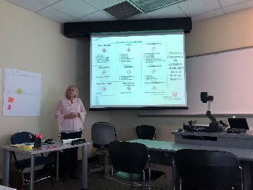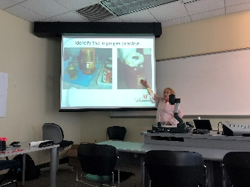

Fig. 3: Ellen Elsbernd reviews hazard Fig. 4: Reviewing photos of improper
symbols in labs. lab practices.

Finally, Ms. Elsbernd reviewed methods and best practices for controlling exposures, and how to effectively use equipment to minimize exposure to hazardous chemicals. She emphasized that the best approach was to be proactive and cautious when interacting with hazardous materials, and to incorporate good hygiene and work practices in the classroom. Some examples of this might include washing hands thoroughly, not preparing or storing consumables in the laboratory, and using secondary containment to transport chemicals. Using personal protective equipment was also recommended if other controls are not an adequate form of protection. Proper disposal of hazardous chemical waste was reviewed in order to best equip participants for avoiding unnecessary cross-contamination or environmental pollution. A key component of the workshop was to expect emergencies and spills to occur in order to be best prepared in the likelihood that they do occur. To end the workshop, Ms. Elsbernd reviewed different scenarios and pictures which displayed proper and improper practices, and RET participants identified the practices and possible improvements based on the pictures, as seen in Figure 4. This workshop was essential in order to prepare participants to safely participate in lab research and be best prepared in the case of emergencies.

